**Task1:**

Given a list of strings - List[String] (“alpha”, “gamma”, “omega”, “zeta”, “beta”)

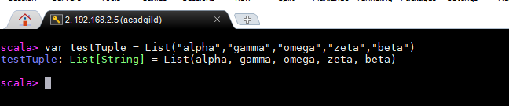

1. Find count of all strings with length 4.

***Scala command : testTuple.count(x => x.length == 4)***

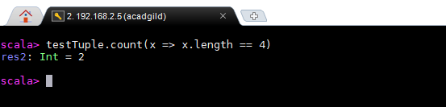

1. Convert the list of string to a list of integers, where each string is mapped to its

corresponding length.

***Scala command : testTuple.map(x => x.length)***

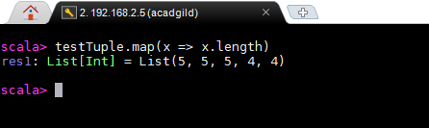

1. Find count of all strings which contain alphabet ‘m’.

***Scala command: testTuple.count(x => x.contains("m"))***

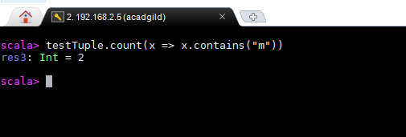

1. Find the count of all strings which start with the alphabet ‘a’.

***Scala command:*** ***testTuple.count(x => x.charAt(0) == 'a')***

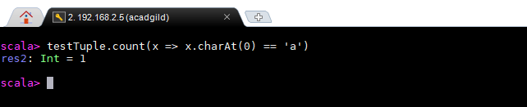

**Task 2**

Create a list of tuples, where the 1st element of the tuple is an int and the second

element is a string.

Example - ((1, “alpha”), (2, “beta”), (3, “gamma”), (4, “zeta”), (5, “omega”))

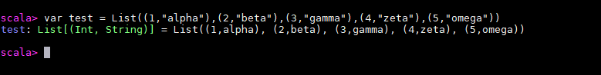

1. For the above list, print the numbers where the corresponding string length is 4.

***Scala command : test.filter(x => x._2.length == 4).foreach(x => println(x._1))***

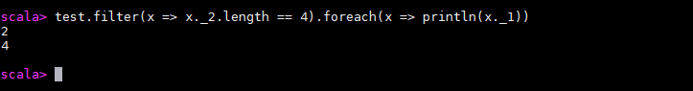

1. find the average of all numbers, where the corresponding string contains alphabet ‘m’

or alphabet ‘z’.

***Scala command : var tuple = test.filter(x => x._2.contains("m") || x._2.contains("z"))***

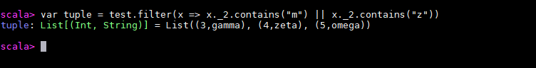

***Scala command : tuple.map(_._1).sum/tuple.size***

